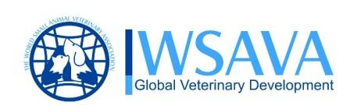
WSAVA Monthly NEWs – NOVEMBER 2010

Get Ready for WSAVA World Congress 2011!
 Welcome to Jeju Island，Korea 

Honorary Ambassador Joon-ho Jung for WSAVA 2011!

Joon-ho Jung was appointed as honorary ambassador for the 2011 WSAVA∙FASAVA World Congress by Korean organizing committee. Inviting Jung as honorary ambassador was unanimously agreed by all committee members as Jung is not only a renowned top-class movie star performed in smash hit dramas and movies but also keeps his animal friendly warm personality.

The Warmest Welcome from KAHA President Jong-II Kang

Fellow veterinarians,

On behalf of the 2011 WSAVA•FASAVA World Congress Organizing Committee, I am very pleased to invite you to the 2011 WSAVA•FASAVA World Congress, to be held on October 14 ~ 17, 2011 in Jeju Island, the Republic of Korea.

The 2011 WSAVA•FASAVA World Congress Organizing Committee is preparing for the event to make it a site for exchanging the latest information on veterinary medicine and making friends among fellow veterinarians from all over the world while enjoying a variety of sideline events.

The 2011 WSAVA•FASAVA World Congress will be a high-class congress that offers lectures by top-notch scholars and experts in veterinary science around the world and the latest trends and information on advanced technologies in veterinary science. In order to present a high-quality academic congress, the Organizing Committee has cooperated consistently and closely with various international veterinary associations with the WSAVA Headquarters as the liaison office for various matters related to the event, including the schedule and selection of the lecturers and the topics. As a result, the congress will feature some 250 lectures delivered by 91 scholars in 33 topics.

The congress will be held for four days from Friday to Monday for the convenience of all participants, including veterinary practitioners and scholars. All participants will be given a certificate of participation. Especially, the veterinarians from Korea and the U.S will be awarded continuing education credit (CE credit). While English will be used as the official language during the congress, but a simultaneous interpretation service in Japanese, Chinese and Korean will be available for the lectures that a certain number of non-English-speaking participants want. In addition, multi-language services will be provided during the congress for the convenience of the participants from non-English-speaking countries.

Jeju Island, the venue of the 2011 WSAVA•FASAVA World Congress, is a beautiful place designated as a World Natural Heritage site by UNESCO for its natural beauty, unique culture and clean and comfortable resorts. Also, Korea is a dynamic country with 5,000-year history, boasting numerous historical and recreational sites.

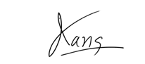
Jong-Il Kang, DVM
9th President, Korean Animal Hospital Association /
Director of Committee At-Large, 2011 WSAVA•FASAVA World Congress

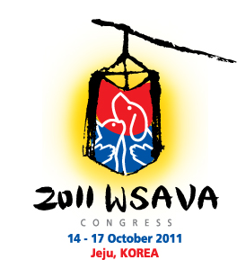 | The Theme of Emblem  We used the image of the Korean traditional lantern, chung-sa-cho-rong to emphasize the Korean image of practice, enlightenment, welcome, and hope. Within this image, small animals and the bright light become one to symbolize the light of hope this congress. By using a brush technique and the red the blue of the ying & yang, we tried to differentiate the symbol for the Korean congress from meetings in previous years.

Title | 2011 WSAVA∙FASAVA World Congress  36th World Small Animal Veterinary Association World Congress  3rd Federation of Asian Small Animal Veterinary Associations Congress
Date | October 14(Fri) ~ 17(Mon), 2011  ※October 13(Thu) : WSAVA General Assembly Meeting, Pre-Congress Special Program
Place | International Convention Center Jeju (ICC Jeju), KOREA

Past WSAVA World Congresses
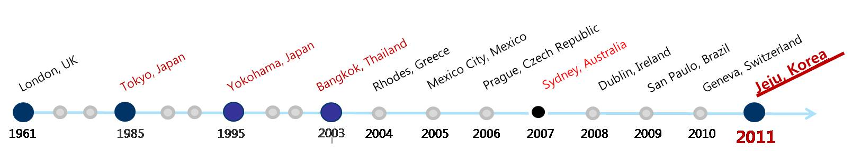

Past FASAVA congresses

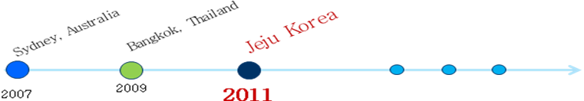

About FASAVA 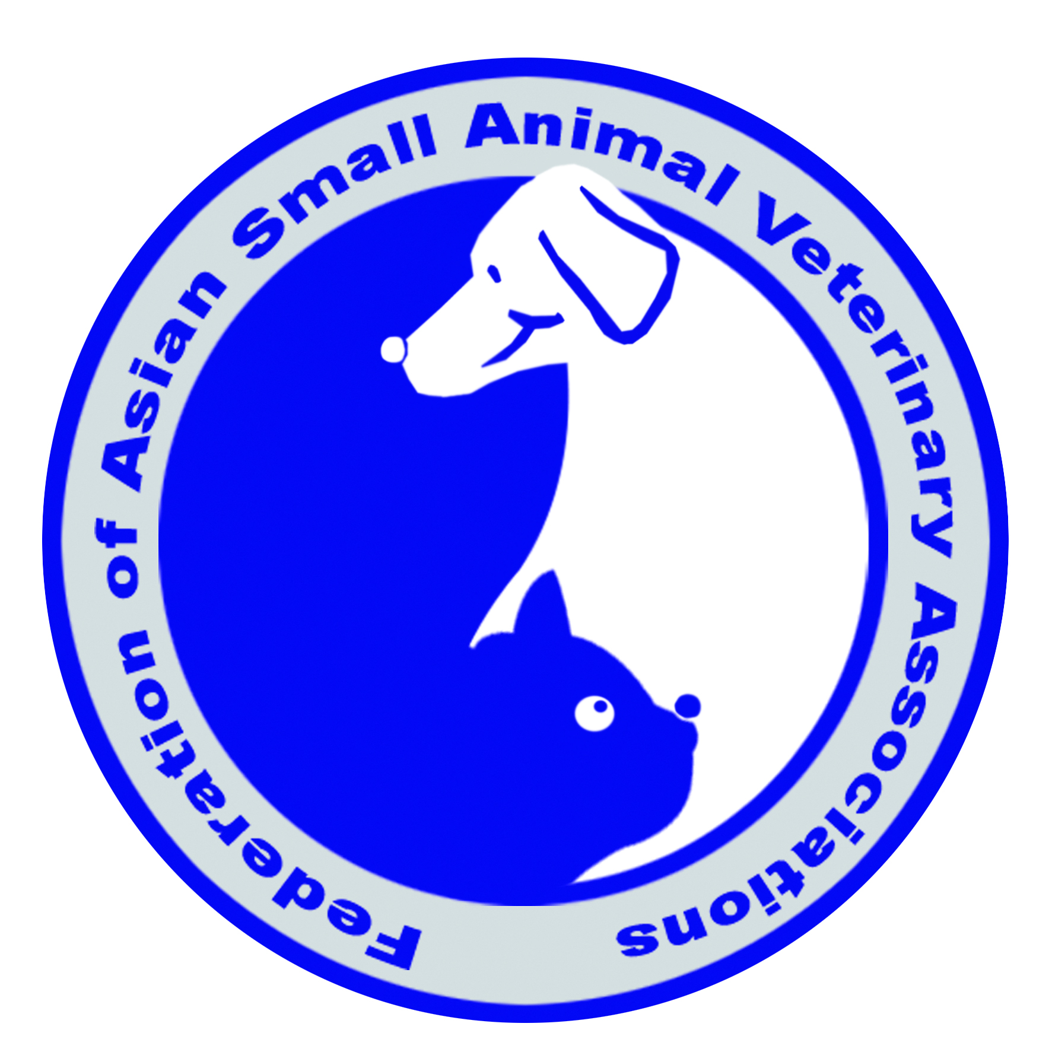

FASAVA is a non-profit organization that was formed to encourage communication and cooperation between veterinarians throughout the Asian Pacific region and to promote the adoption of new technology and techniques. Its objective is to develop and increase the status of veterinary knowledge in the Asian Pacific region in order to substantially improve the welfare and health of animals in the Asian region.

Congress is held biannually and member countries including Australia, Hon Kong, Korea, Malaysia, New Zealand, Thai, Taipei etc are getting wider.

WSAVA State of the Art Lectures

- Acupuncture / Herb
- Animal Welfare
- Behaviour
- Cardiology and Pulmonology
- Critical Care and Anaesthesiology & Traumatology
- Cytology, Haematology & Clinical Pathology
- Dentistry
- Dermatology
- Diagnostic Imaging
- Ear-Nose-Throat
- Endocrinology
- Exotics
- Feline Medicine
- Gastroenterology
- Hepatology
- Hereditary & Genetic Diseases
- Parasitic Diseases
- Medicine (Standards of Care)
- Nephrology & Urology
- Nutrition
- Pharmacology
- Reproduction
- Surgery (Soft Tissue Surgery)
- Surgery (Orthopaedics Surgery)
- Surgery (Onco-surgery)
- Veterinary Management
- NAVC – Oncology
- NAVC – Ophthalmology
- WSAVA Award Lectures

WSAVA 2011 Promotional event at JSAVA
• Title : JSAVA 2010 Annual Meeting
• Date : August 28~29, 2010
• Venue : Tokyo, Japan
• Promotional Content: Promotion booth & promotional presentation at welcome reception

Registration

• Early-Bird Registration: January 1, 2011 ~ February 28, 2011
• Pre-Registration: March 1, 2011 ~ September 30, 2011

Please contact: wsava2011@unineo.com or visit below website for more information: http://www.wsava2010.org

The 1st International One Health Congress
Melbourne, Victoria, Australia
14 – 16 February 2011
This 1st International One Health Congress will focus clearly on the risks and challenges brought about by the interactions between animal and human health and the environment. It will consider these in the general context of the science and research being undertaken, but critically it will focus on the outcomes that need to be achieved to effectively manage the growing risks to global health.
The congress aims to provide an opportunity to think “outside the box” and into the future in order to make recommendations on policy and organisational changes using the underlying science to inform and drive the process. For the first time, it is envisaged that a global consideration of interrelated issues of animal and human health and the relationship with the environment can take the science to the policy maker and thus drive real and profound change. We see this as setting a pathway that in 10 -15 years will result in a seamless approach to infectious disease management with both the resources and those with the skills and knowledge intimately linked.
Thus we expect the meeting to define the current situation, and based on this knowledge, to develop a vision of the major public health issues and needs in the next 15 years. Many of these issues are with us now, especially those driven by environmental factors such as global warming and increasing pressures on land usage and fresh water requirements, but we need to approach these issues in a holistic and cooperative way if we want to be able to predict and respond to outbreaks of emerging diseases with greater certainty and speed, and in so doing, ensure our world remains healthy environment for our children.
Selected recently as the most livable city in the world, Melbourne is renowned as a global sports capital. Melbourne and the surrounding area offer everyone something in which to delight. So the invitation goes beyond the science and thought and extends to enjoying all that Australia has to offer as a unique global venue for such meetings.
Drs. Michael Days and Diane Sheehan will represent The WSAVA One Health Committee to give presentations on “Positioning Companion Animals in Global Infectious Disease Surveillance” and “Promoting Comparative Clinical Research – the Value of the Companion Animal Model”.
We look forward to sharing this with you in February 2011.
www.OneHealth2011.com

