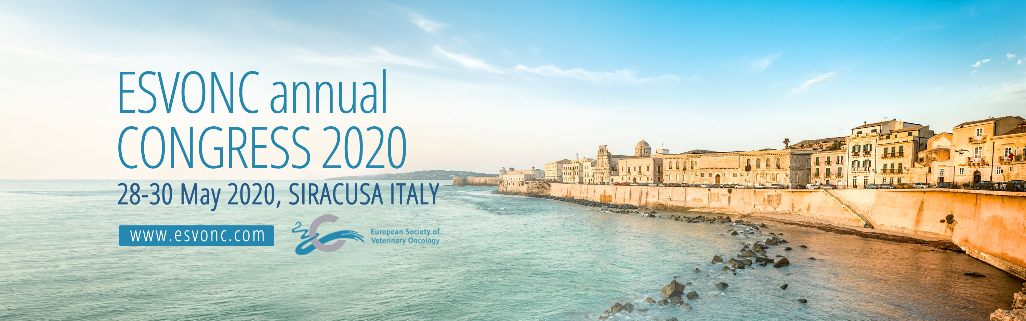

First came the Greeks, then the Romans, the Moors, the Normans and Vikings (yes, really), all conquered and ruled and fought over this pivotal city at the heart of the Mediterranean. Now oncologists…and medics and surgeons, clinical pathologists and diagnostic imagers will come, not to conquer, but to discuss and debate, educate and learn…will you be among this peaceful invasion?

The ESVONC family will welcome you to 3 days of stimulating lectures, to an evening of culture with a tour of the city on land and sea…to sample fine Sicilian cuisine in the ancient Greek quarries of Latomia del Casale.

THURSDAY: Endocrine neoplasia will stimulate the medics and surgeons

FRIDAY: Rescue protocols and interventional radiology…when first line fails, something for the clin paths and radiologists

SATURDAY: Advanced imaging; Changing oncology, made for the imagers

And if you fancy something truly oncological…try Wednesday’s pre-congress resident’s session on Angiogenesis and Cancer

For the full programme go to www.esvonc.com, details about Siracusa are available at www.secretsyracusa.it

Come and join us in this quest for knowledge at the Teatro Comunale in Siracusa from 28th to 30th May 2020. (Pre-congress on the 27th).

